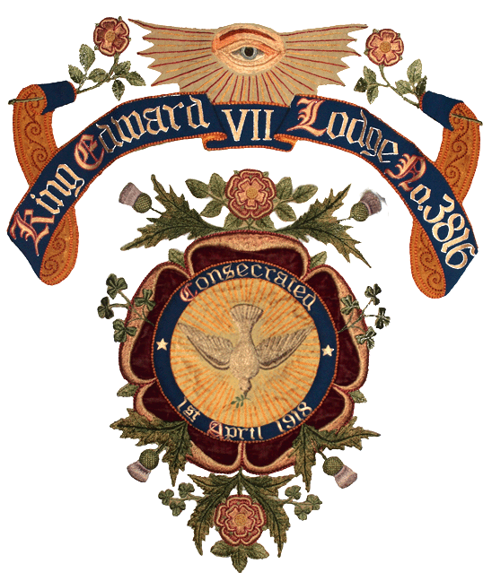
KING EDWARD VII LODGE No. 3716
Province of Hampshire & Isle of Wight
King Edward VII Lodge, named after the former King who himself was an eminent freemason, was formed at the end of the ‘Great War’ of 1914-1918 by the then Mayor of Portsmouth, Sir George Couzens in order to serve the North End area of Portsmouth. The Lodge was formally consecrated in April 1918 and has met regularly ever since. For the last 50 years, King Edward VII Lodge has been based at the Cosham Masonic Centre. Membership nowadays is drawn from a much wider area as travel and transport is significantly easier!

Membership is open to all men over the age of 18
Lodge Secretary: Colin Chiddicks
Secretary’s email: kevii3816secretary@outlook.com
Meetings: 7 times a year on the 4th Tuesday of the months from October to April, at Cosham Masonic Centre, Albert Road, Cosham
Time of meetings: 6pm
Installation Meeting: April
Subscriptions for 2023: £140

The lodge also holds a number of social events throughout the year to which wives, partners and friends are invited.

For more information please see our website at kevii3816.com or email the secretary.

